Rename the file to this format: M6-Lab03-yourname.docx or pdf
Class & Module | SAH  Lab03: Evaluating Supervised Learning Models/ Assignment3
Name | Goh Rui Kun
IC No. [S****123X] | S****836J
Date & Time | 19th Feb 9pm

Create screenshot following the instruction below:
Step 1 of 4
- Following lab instruction, Upload the CSV (flights.csv) either using Azure Storage Explorer or Azure portal to Azure storage BLOB container in the folder named “data”
- then upload the python notebook: Python Classification Evaluation.ipynb
- complete to run the steps in the jupyter notebook

create - paste the screenshot on the result of #Recalculate Confusion Matrix in the las cell
*** place here the screenshot of your data folder ***
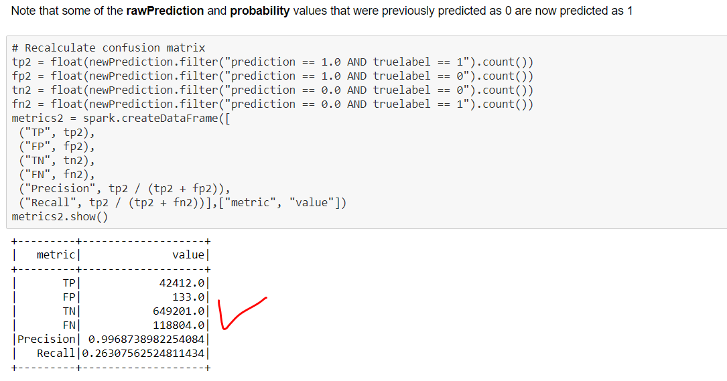

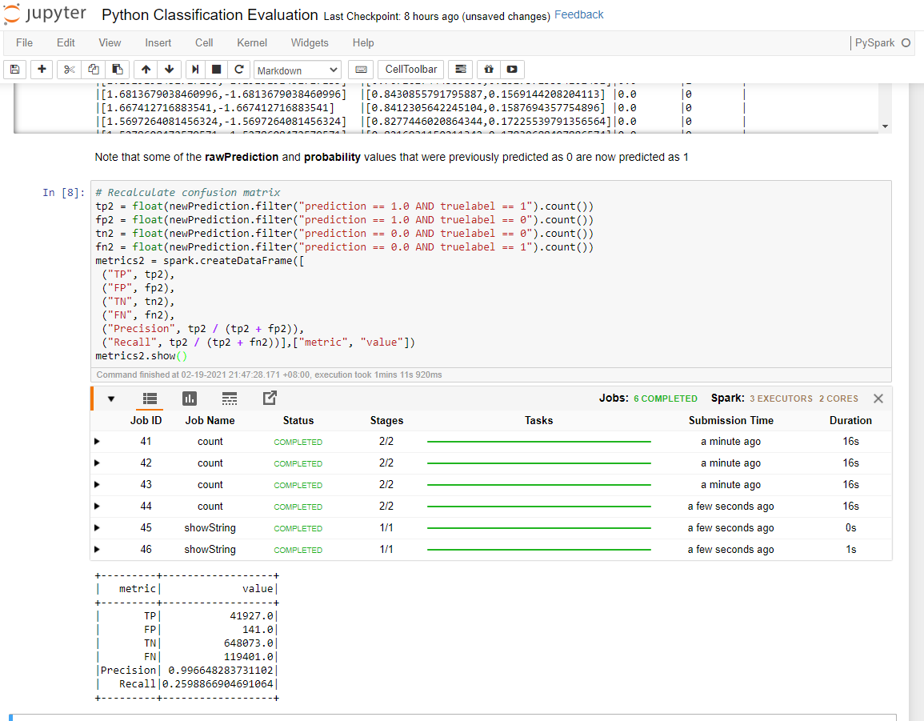

Step 2 of 4
- Following lab instruction, Upload the CSV (flights.csv) either using Azure Storage Explorer or Azure portal to Azure storage BLOB container in the folder named “data”
- then upload the python notebook: Python Cross Validation.ipynb
- complete to run the steps in the jupyter notebook

create - paste the screenshot on the result of RegressionEvaluator showing RMSE of the prediction
*** place here the screenshot of your data folder ***
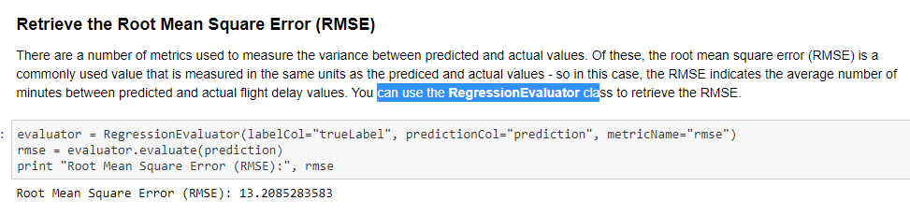

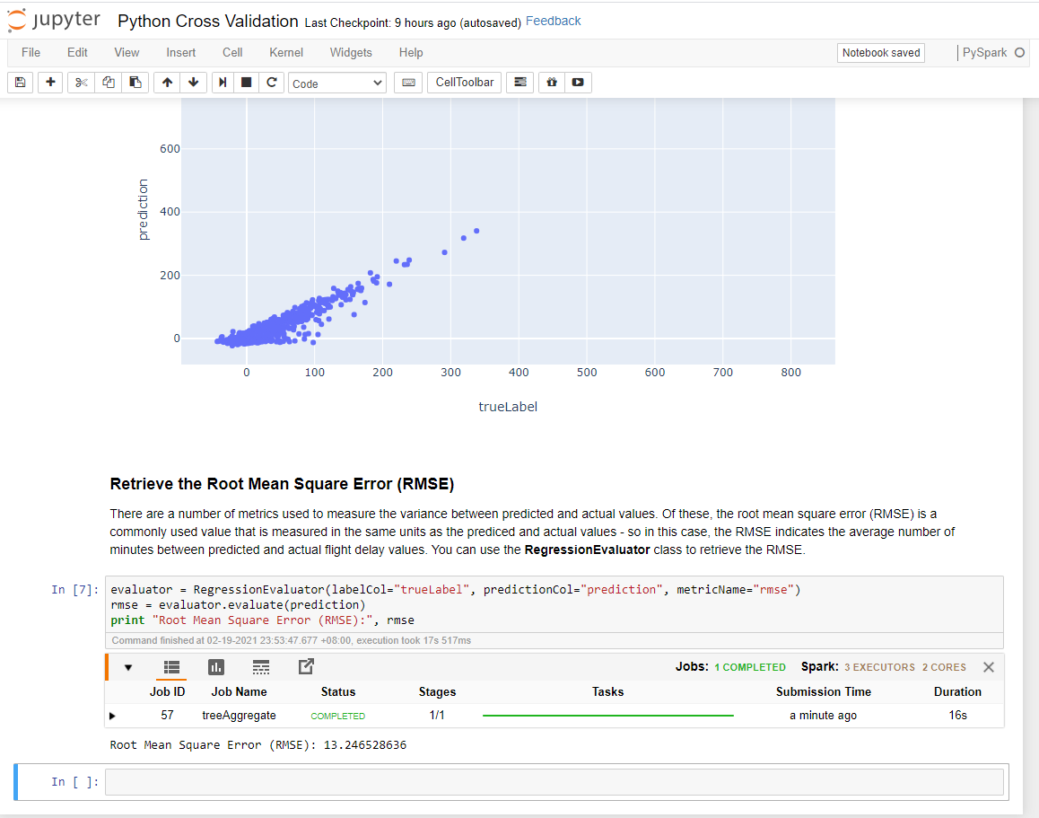

Step 3 of 4
- Following lab instruction, Upload the CSV (flights.csv) either using Azure Storage Explorer or Azure portal to Azure storage BLOB container in the folder named “data”
- then upload the python notebook: Python Parameter Tuning.ipynb
- complete to run the steps in the jupyter notebook

create - paste the screenshot on the result of Binary Classification Evaluator showing the AUR of the result
*** place here the screenshot of your data folder ***
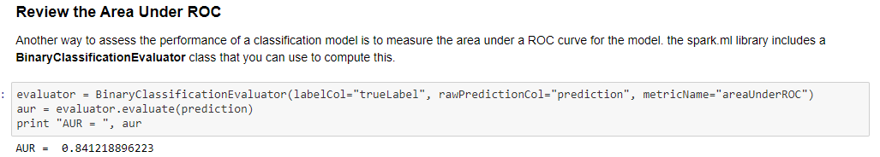

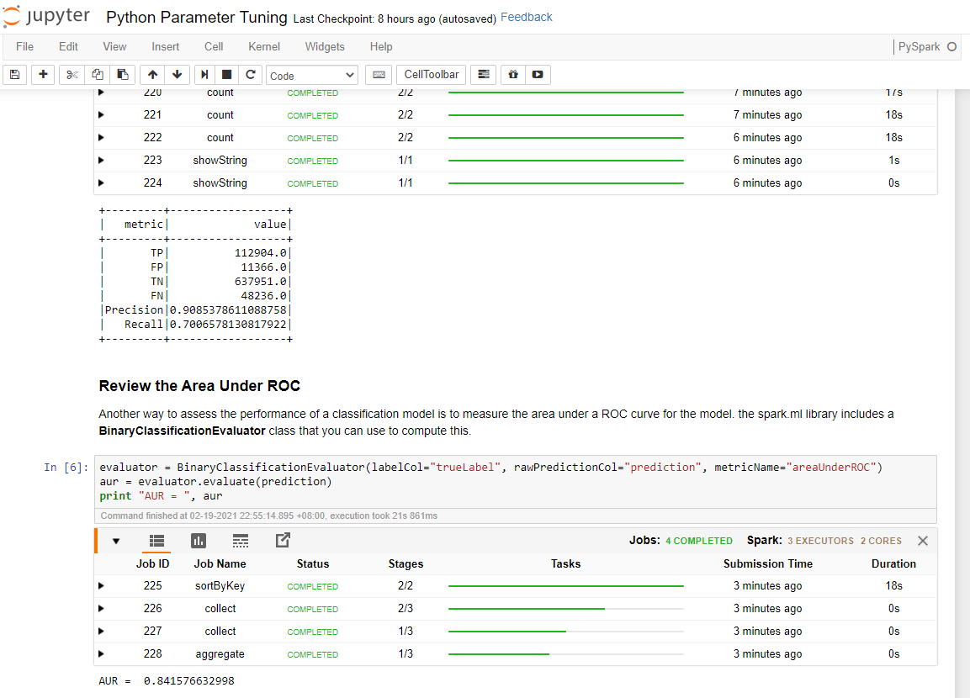

Step 4 of 4
- Following lab instruction, Upload the CSV (tweets.csv) either using Azure Storage Explorer or Azure portal to Azure storage BLOB container in the folder named “data”
- then upload the python notebook: Python Regression Evaluation.ipynb
- complete to run the steps in the jupyter notebook

create - paste the screenshot on the result of RegressionEvaluator showing the RMSE of the prediction
*** place here the screenshot of your data folder ***
